EXPERIMENT 8

Aim: To create an infographic explaining the concept of Public Land Mobile Network using Figma.
Procedure:
- Open Figma and create a new design file.
- Add the title “Public Land Mobile Network (PLMN).”
- Draw mobile phones, cell towers, and a network operator.
- Connect the elements using arrows.
- Add labels explaining mobile users, base stations, and the core network.
- Use different colors and simple icons to make the infographic clear.
OUTPUT:
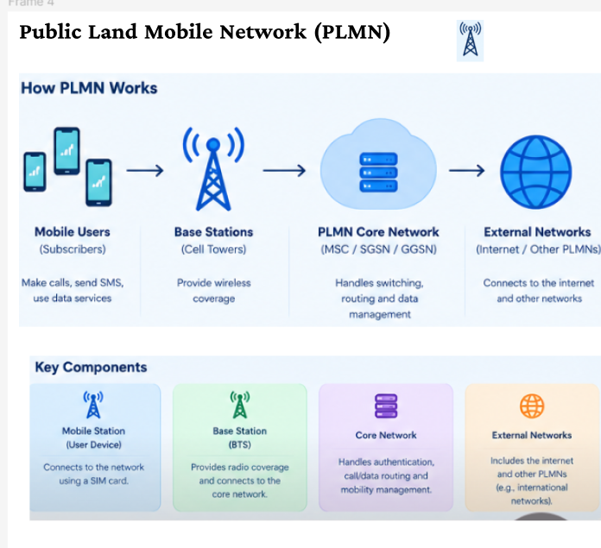

FIGMALINK: https://www.figma.com/design/ED1qcVpNfWi2Zuft4amJyZ/Untitled?node-id=55-14&t=uA2KDN40aNTshT4h-0

RESULT: A PLMN infographic was created successfully using Figma.

